

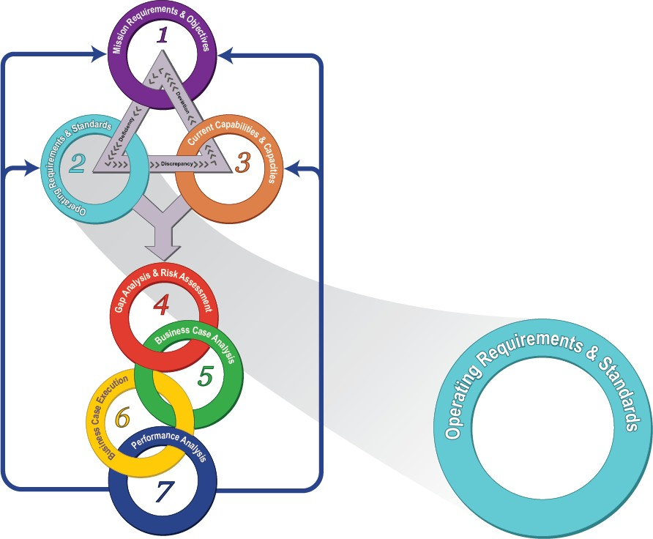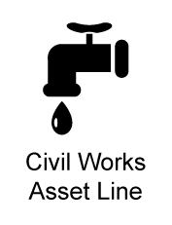
Configuration
Standard
Technical Order
Mission Support Business Model

Advanced Metering Infrastructure
SILC-CSTO-36-11 31 17 11-01


Commander
U.S. Coast Guard
Shore Infrastructure Logistics Center
300 East Main Street, Suite 800
Norfolk, VA 23510-9104 Staff Symbol: (esd) Phone: (757) 628-4277

4100
03 JUL 2018
Subject: | ADVANCED METERING INFRASTRUCTURE CSTO
Ref: | - Civil Engineering Manual, COMDTINST M11000.11 (series)  - Shore Infrastructure – Mission Support Business Model Requirements Directive Technical Order, SILC-RDTO-36-11 29 11 00-01 (latest)

- PURPOSE. This Configuration Standard Technical Order (CSTO) provides the framework to standardize advanced metering requirements for electricity, natural gas, propane, potable water, and non-potable water as applicable (i.e. irrigation). The configuration established herein enables Coast Guard facilities to comply with federally mandated benchmarking and reporting requirements to optimize and reduce energy consumption, and will be used to establish metering requirements across the Coast Guard’s shore infrastructure.

- ACTION. This technical order shall be used by all design engineers (Civil Engineering Units, Facilities Design & Construction Center, and unit level Facility Engineering Departments) to plan, design, and install advanced metering for utilities infrastructure servicing “appropriate” covered buildings and tactical end points. Energy Managers, Water Resource Managers, Facility Engineers, Facility Asset Managers, Sector Engineering Officers, Engineering Petty Officers, and other facility managers and technical staff shall use this technical order for operation, maintenance, and to ensure that any changes made to advanced metering are in accordance with this configuration standard.

- AUTHORIZATION. This technical order has been reviewed and is authorized by the SILC Configuration Control Board.

- DIRECTIVES / TECHNICAL ORDERS AFFECTED. A Process Guide Technical Order (PGTO) for installation and commissioning, to include a System Operational Verification Test (SOVT), is subservient to this technical order. High level process steps for installation and commissioning are outlined herein.

- ENVIRONMENTAL ASPECT AND IMPACT CONSIDERATIONS.
  - The general policies contained in this technical order are categorically excluded under current USCG categorical exclusion #33 from further environmental analysis, in accordance with the National Environmental Policy Act Implementing Procedures and Policy for Considering Environmental Impacts, COMDTINST M16475.1 (series).
  - All future specific actions resulting from the general policies in this technical order must be individually evaluated for compliance with the National Environmental Policy Act (NEPA), Council on Environmental Quality NEPA regulations at 40 CFR Parts 1500-1508, DHS and Coast Guard NEPA policy, and compliance with all other environmental mandates.

- DISTRIBUTION. SILC Business Operations Division (BOD) posts an electronic version of this technical order in CG-TIMS, and will place a link to the document in the Approved Technical Order List on SILC's Configuration Management site on the CG Portal. No paper distribution will be made of this document.

- SCOPE. The standards described in this technical order shall be implemented in accordance the following constraints:

  - TECHNICAL AUTHORITY. The technical authority for this technical order is SILC Commander. Additional roles and responsibilities are identified in Section 1.4 of this technical order.
  - ASSETS / SERVICES. This technical order defines the functional configuration requirements for Utility Systems throughout the Coast Guard. Applicable assets are listed in Section 1.3 of this technical order.
- TRAINING. Training will be available in multiple formats through the use of technical notes, job guides and job aides. These instructions are posted on the Advanced Metering CG Portal Page (http://cglink.uscg.mil/AMI). Training will be provided for the user to operate and maintain the equipment installed at each facility, as well as for the personnel that support the equipment.

- DEVELOPMENT TEAM. The following authorities and subject matter experts were significantly involved in producing this technical order.

Name | Position | Organization
CDR Michael Roschel | Mission Support Product Line (MSPL) Manager | CEU Providence
LCDR Mike Cost | Deputy Mission Support Product Line Manager | CEU Providence
LCDR Lawrence Tormey | Mission Support Asset Line Branch Chief | SILC Mission Support Product Line
Catherine LaBranche | Asset Line Manager(ALM) / TO Author | Civil Works Asset Line (CIVW)
Tony vanWinden | Facilities Engineering | TRACEN Petaluma
ETC Seth Endter | Electronics Technician Chief | TRACEN Petaluma
Tina Hamilton | Information Technology ALM | OSC Logistics Product Line
John Regan | Design Section Chief | FDCC Project Execution Branch
Paul Miller | Asset Line Analyst | Jacobs
John Harsche | Resource Efficiency Manager | Tetra Tech, Inc.

- FORMS / REPORTS. None.

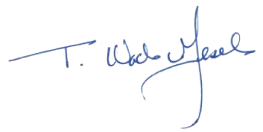
- REQUEST FOR CHANGES. Submit recommendations for TO improvements or corrections through the Engineering Change Proposal form in SILC's Configuration Management site on the CG Portal.

T. WADE GESELE Captain, U.S. Coast Guard

TABLE OF CONTENTS
- Overview 1
  - Configuration Standard Summary 1
  - Advanced Meters vs Standard Meters 2
  - Applicability 2
  - Roles and Responsibilities 3
- Advanced metering Selection 5
  - Qualification 5
  - Prioritization 8
- Technical Requirements 9
  - Organization 9
  - Equipment Requirements 9
    - General Requirements 9
    - Electrical Meters 9
    - Natural Gas or Propane Meters 10
    - Water Meters 11
    - Data Acquisition Servers 14
    - Transceivers 15
  - Data Communications and Configuration 16
    - Data Communications 16
    - Key Data Fields 17
    - Recording Intervals 19
- EXECUTION 20
  - Installation and Commissioning 20
    - Meters 21
    - Data Acquisition Servers (DAS) 22
    - Transceivers 22
  - Submittals 23
  - Maintenance 24
- References 26
  - Process Relationships 26
  - Referenced Documents 26
- Definitions 29
Appendix A – Business Case Analysis................................................................................................. A-1
Appendix B – Data Acquisition Server (DAS) Specifications ............................................................. B-1
Appendix C – Wireless ModBus/Pulse Transceiver ............................................................................ C-1
Appendix D – SAMPLE Justification and Accountability (J&A) ......................................................... D-1 Appendix E – Sample Statement of Work..............................................................................................E-1
Appendix F – Advanced Metering Equipment Naming Convention ...................................................F-1

OVERVIEW

Configuration Standard Summary
The Energy Policy Act of 2005 (EPAct) and the Energy Independence and Security Act of 2007 (EISA 2007) require metering of electricity, natural gas, propane, potable water, and non- potable water utility consumption at the building level for all federal facilities meeting thresholds as established by the Federal Energy Management Program (FEMP). Furthermore, the information (data) collected from the metering shall comply with the mandated benchmarking and reporting requirements for optimizing and reducing energy consumption in accordance with these federal mandates.
This CSTO will outline the specific considerations of Advanced Meters, which exist within the context of a larger Energy Management Program. This program includes interactions between CG-46 and the Shore Infrastructure Logistics Center Engineering Services Division, Energy Branch (SILC – ESD-Energy), Engineer Officers, Engineer Petty Officers (EPOs), Facility Engineers (FEs), Design Engineers and all other Coast Guard personnel who manage or monitor energy consumption and make use of the collected information. Figure 1 shows the wider context of those relationships, while Table 1-3 shows the roles and responsibilities as they pertain to this CSTO.

AMI Program Responsibilities
SILC ESD  Energy Branch | SILC BOD | CG-6 | FE/EPO | CG-46 | Design Engineer  (FD&CC, CEU,HQFE) | SILC  Product Line
Provide EDMS  Requirements | Collaborate on EDMS/Data Acquisition Interface | Support EDMS  Server Application | Provide Guidance for AMI  Installation | Provide Energy Requirements | Qualifies AMI for Inclusion in facility Design | Manage AMI Equipment Configuration
Support AMI Data Management and Connectivity | Support EDMS  Application | Support EDMS  Database | Oversees AMI  Installation | Report Savings  Achieved thru AMI | Develops/ or Includes Plans and Specifications for AMI Installations | Support AMI Hardware Requirements
Prioritizes AMI Projects Perform Energy Audits  Thru REMs | Support AMI Data Management | Support EDMS  Client | Perform AMI Maintenance
Perform Energy Analysis |  | Manage Network at Site | Perform Energy Analysis
Figure 1: AMI Program Relationships

Advanced Meters vs Standard Meters
It is important to differentiate the advanced meter equipment detailed herein from standard energy and consumption meters. The latter are electromechanical or solid state meters that cumulatively measure, record, and store aggregated usage data that are periodically retrieved for use in customer billing or energy management. In contrast, advanced meters are those that have the capability to measure and record interval data (at least hourly for electricity) and communicate the data to a remote location in a format that can be easily integrated into an advanced metering system. These advanced meters commonly measure every 15 minutes to match utility billing intervals. Other intervals (e.g., 1 minute, 5 minute, hourly) can be accessed and are useful for examining equipment performance, trending, and start/stop characteristics. Measuring consumption, collecting data, and analyzing at the whole building, sub-panel, or even specific end-use levels allow for effective decision making to best maintain systems and ultimately reduce utility consumption through awareness and optimizing equipment performance.
Most United States Coast Guard (USCG) sites and facilities were originally constructed with utilities measured via standard usage meters only at incoming site area or within other agency jurisdictions. These meters are known as master meters and only track cumulative usage of multiple buildings at infrequent intervals. This level of usage metering does not comply with the federal mandates for detailed tracking of specific facilities (buildings, shore ties, equipment etc.).
While advanced metering for steam is recommended at the building level per federal guidance, there is not a business case for advanced metering of steam within Coast Guard facilities.
Similarly, fuel oil consumption is consistent only with standard metering. As these do not require advanced interval based consumption measurements, steam and fuel oil are not referenced in this CSTO.
The configuration for the Advanced Metering System documented in this CSTO began from the initial phase of the Advanced Metering Initiative (AMI) Project in 2012. During this initial rollout of the AMI, equipment from Obvius LLC., an energy solutions provider, was selected as the standard configuration for Data Acquisition Servers (DAS) and Transceivers. Over 1960 advanced electrical meters were installed in Coast Guard buildings at appropriate assets – buildings equal or greater than 5000 SF, buildings with high energy use, select family housing and tactical assets (shore ties).

Applicability
This technical order applies to utilities assets, as defined by the USCG Facilities Classification Guide, and listed in Table 1-1. Table 1-2 defines the Advanced Metering Equipment and associated Level IV Uniformats.
Facilities which are required to be metered with advanced meters shall be determined through Qualification and Prioritization processes as described in Section 2.

Table 1-1: Applicable Assets Listed by CATCODE

CATCODE | CATCODE Description
811-46 | Electric Power - Wind Turbine
811-48 | Alt Energy Source Power not Solar/Wind
811-50 | Solar Array or Photovoltaic System
812-01 | Electrical Distribution System
812-31 | Electrical Power Distribution Line, Overhead
812-32 | Electrical Power Distribution Line, Underground
822-12 | Heat Distribution Line
824-10 | Heat Gas Distribution Line
827-20 | Chilled Water and Refrigerant Distribution Line
842-10 | Water Distribution Line, Potable
843-10 | Water Distribution Line, Fire Protection
845-20 | Water Distribution Line, Non-Potable

Table 1-2: Applicable Equipment Uniformat

Uniformat | Equipment Description | Feature ID
D509081 | Data Acquisition Server | DAS
D501081 | Electrical Advanced Meter | EAM
D301081 | Gas Advanced Meter | GAM
D202081 | Water Advanced Meter | WAM
D509082 | Transceiver (Modhopper) | XCVR
D509083 | I/O Flex Module | IOM

Roles and Responsibilities
The technical authority for this configuration standard is the SILC Commander. Table 1-3 enumerates the roles and responsibilities for establishing the standards defined in this technical order. The following “RASCI” codes are used:
R - Responsible – Those who do the work (typically only one Responsible per task).
A - Approver – The one ultimately accountable for the deliverable or task (must have only one Approver per task).
S - Supports – Those who provide resources, information, expertise or other assistance in completing the task.
C - Consulted – Those whose opinions are sought (two-way communications).
I - Informed – Those who are kept up-to-date on progress (one-way communication).

Table 1-3: Roles and Responsibilities

Task, Deliverable, or Responsibility | SILC - BOD | SILC – ESD - ENERGY | MSPL PLM | CIVW ALM | DESIGN ENGINEER | FE / EPO | CG-46 | Contractor | CG-6
Establish Configuration Standards | I | C | A | R | C | C | S |  | S
Manage Utilities Configuration |  |  | A | R |  | C |  | C
Qualify and Prioritize Metering Projects |  | A/R |  | C | R
Manage Equipment Installation |  | C |  | A |  | R |  | I
Perform Maintenance |  | A |  | I |  | R
Manage Network Infrastructure | A | C |  | I |  | I |  |  | R

ADVANCED METERING SELECTION

Selection of advanced metering shall undergo a two-step process. The first step is to qualify which facilities or assets are required and appropriate or fiscally reasonable to meter (MSPL should be consulted when making this decision). The second step is to prioritize the list of metering projects or responsibilities.

Qualification
The factors of utility qualification for advanced metering are comprised from federal mandates, and generally include requirements for installation at “appropriate assets” defined as covered buildings, smaller facilities, and equipment necessary for optimization of building operations, selected family housing communities, and connections for tactical assets. Key federal guidance includes the Energy Policy Act of 2005 - Section 103, EISA 2007, Executive Order 13963 and the Federal Energy Management Program for Metering Best Practices.
DHS and Coast Guard guidance include Shore Facilities Utilities Metering Guidance Memorandum, and the U.S. Department of Homeland Security Metering Plan (See Section 5.2 Referenced Documents).
Coast Guard guidance specifically requires that advanced meters meet the full intent of EPAct 2005 and shall be installed on any new construction or major renovation of $200,000 or above (when it is cost effective). All shore ties and new renewable energy projects are included in this guidance. Specifically, the guidance dictates that advanced meters shall be included as an Energy Conservation Measure (ECM) in the Energy Savings Performance Contracts (ESPC)/ Utility Energy Service Contracts (UESC) projects – FEMP O&M 3.0. Additionally the guidance calls for a concentrated effort to meter building energy consumption on a sub-building level though sub-metering for certain building types, for example data centers, as energy use has increased significantly over the years in these facilities. Water meters should be installed based on water use and flow at the whole building level. The water meters must comply with all federal requirements for potable and process water use reporting requirements. Additionally advanced water meters are required for specialized use such as central boiler or chilled water plants, and high water use activities such as piers and vehicle washing stations shall be installed.
Figure 2 provides a decision matrix to guide the selection of applicable assets. The first step of selection involves potential inclusion/exclusion criteria to advanced metering. These include facilities or assets that will be removed from inventory, whether the operational security of the facility is such that data collection would be disallowed or problematic, etc. The thresholds for advanced metering are summarized in Table 2-1 and Table 2-2, adapted from the U.S. Department of Homeland Security Metering Plan, November 2015. Appendix A provides the Business Case for determining practicability for installation of an advanced meter.

AM
VA

YE S
N O
YES
Start
Sold or
razed NO
within the next five years?
Facility Modific ation Allowed
?
YE S
Operati onal Security
Exclusio
NO
n ?

Exceed thresh olds per
YESI CSTO
?
N O
High usage (Data Center, H Y C,
etc.)
N O
YES
Prioritiz e
M eterin g Projects
YE S
Respon sible for Utility Bills?
NO
Will Operatio ns Benefit from
M eter?
No Adva nced M eter
NO
Figure 2: Facility Qualification Decision Matrix

Table 2-1: Advanced Energy (Electricity and Natural Gas / Propane) Meter Thresholds*

Facility Function | Real Property Use or Category Code | Size SF(Greater than or Equal)
All Other Land ** | 80 | 5,000
Communications Systems | 72 | 5,000
Dormitories/Barracks | 31 | 5,000
Hospital | 21 | 5,000
Housing | 30 | 5,000
Industrial*** | 50 | 5,000
Laboratories | 74 | 5,000
Museum | 28 | 5,000

Facility Function | Real Property Use or Category Code | Size SF(Greater than or Equal)
Aids To Navigation(ATON) and Traffic Aids | 73 | 5,000
Office Building Locations | 10 | 5,000
Other Institutional Uses *** | 29 | 5,000
Post Office | 14 | 5,000
School | 23 | 5,000
Service (other than buildings) **** | 60 | 5,000
Warehouses | 41 | 25,000
Pier/Wharf (one meter per shore tie) | 151-20 | Cutters
Pier/Wharf (master meter for all shore ties) | 151-20 | Other Vessels
Aircraft Hangar | 211-05 | 25,000
Exchange Eating Facility | 740-04 | 1,000
Cold Storage Building | 740-24 | 1,000
Recreation Center | 740-28 | 1,000
Bowling Center | 740-40 | 1,000
Golf Club House and Sales | 740-80 | 1,000
* Or as practicable – See Appendix A
** Except 740 CATCODES listed in this table
*** Some facilities < 5,000 may require metering pending energy analysis
**** Except hangars (211-05)

Table 2-2 Advanced Water Meter Thresholds*

Facility Function | Water Usage
Pier/Wharf (one meter per shore tie) | Cutters
Pier/Wharf (master meter for all shore ties) | Other Vessels
Large Water Using Process | > 1,000 gal/day per billing period**
Irrigated Landscape Area | > 25,000 square feet
All Building Functions > 5,000 square feet | > 1,000 gal/day per billing period**
* Or as practicable – See Appendix A
**Use consumption values from design calculations for facility or process

Prioritization
For the purpose of maximizing cost effectiveness, it is recommended that the installation of advanced energy (electricity, water, and natural gas) meters be prioritized using the hierarchy as follows per Federal Building Metering Guidance and Coast Guard Metering Plan:
Energy Metering (Electric and Natural Gas / Propane)
    - New Construction and Major Renovations ($200K or greater).
    - Inclusion on the Energy Independence and Security Act (EISA) Audit Covered facilities list.
    - Shore Ties.
    - Buildings that have been targeted with ESPC or UESC / resource conservation projects.
    - All agency data centers not planned for consolidation or closure.
    - All other known energy-intensive building types (e.g., laboratories, hospitals, control towers, and food services).
    - All individual buildings 10,000 square feet or above.
    - All large energy-consuming mission support processes (training systems, industrial systems, communication transmitters, ship cold iron services, etc.).
    - All High Performance and Sustainable Buildings, if not already captured above.
    - Remainder of “appropriate” buildings, largest first - 5,000 square feet or above.
Water Metering
- New Constructions and Major Renovations ($200K or greater).
- Covered facilities that are known to be the largest water consumers.
- Shore Ties.
- Buildings that have been targeted with resource conservation projects.
- All well water and other internal supply lines to the installation (campus).
- Sufficient meters or other leak detection devices on distribution lines to effectively identify system losses. Prioritize the largest distribution lines first.
- All water-intensive facilities including chiller plants, barracks, galleys/kitchens, dining facilities, swimming pools, gyms, golf courses, piers, dry docks, vehicle wash stations, industrial facilities, hospitals, prisons, water-intensive laboratories, and large landscape systems.
- All large individual building – 10,000 square feet or above.
- All High Performance and Sustainable Buildings, if not already captured above.
- Remainder of “appropriate” buildings, largest first - 5,000 square feet or above.

TECHNICAL REQUIREMENTS

Organization
The technical requirements section delineates the equipment and software considerations of the Advanced Metering Initiative for utilities. Section 3.2-Equipment Requirements, describes the functional standards when implementing a Utility Advanced Metering System. This section is subdivided by type of utility to be metered and system elements that are common across utility types. Section 3.3- Data Communication and Configuration, describes the standard data elements required to support an Energy Data Management System (EDMS) software tool.
Figure 3 illustrates the Typical Advanced Metering System Diagram for the USCG.

Equipment Requirements
The specific requirements for gathering consumption data from discrete sources (electrical panels, buildings, vessel shore ties, pipes, etc.) are unique among utilities and will be detailed for each utility type in Sections 3.2.1through 3.2.4. The transceivers that collect the source metered data and the data acquisition servers through which the metered data is routed are common across utilities type and will be detailed in Section 3.2.6 and Section 3.3 respectively.

General Requirements
Meters installed shall be compatible with DAS. As of 2017 the DAS’s in place are Model A8812, manufactured by Obvius, LLC.

Electrical Meters

Introduction
This section discusses the most common electrical metering parameters, focusing on parameters that offer the greatest potential for energy and operational efficiency improvements in accordance with the Federal Energy Management Program. Advanced Metering consists of metering components and wireless technology that transmit time interval consumption data from discrete sources (electrical panels, buildings, vessel shore ties, etc.) to a networked solution for storage, monitoring, and analysis via an EDMS.

 | WARNING! Electricity metering can be a complicated and dangerous endeavor; the equipment and procedures discussed here should only be attempted per personnel rating and training in accordance with the Safety and Environmental Health Manual, COMDTINST M5100.47 (series), in compliance with the current edition of National Fire Protection Association (NFPA) 70: National Electrical Code (NEC), and any local or  agency-specific codes or requirements.

Electrical Meter Equipment Specification Standard Configuration
        - The power meter shall be capable of measuring the variables listed in Section 3.3.2.
        - The power meter shall be sized equal to or greater than the circuit’s Overcurrent Protection Device (OCPD), i.e., circuit breaker.

        - The power meter shall support capture of variables at the interval defined in Section 3.3.3.
        - The meter shall report serially over an RS-485 network using the Modbus (RTU) protocol.
        - The power meter shall consist of the required number of solid or split-core current transformers (CTs). Split core CTs shall be hinged at both axes with the power metering electronics embedded inside of the master CT.
        - The meter shall measure demand (kW) and consumption (kWh).
        - The consumption (kWh) variable shall be stored in non-volatile memory and retained in the event of a power outage.
        - The meter shall directly accept any voltage input from 120-480 VAC.
        - The meter shall be calibrated as a system and be accurate to +/- 1% from 5% to 100% of the rated current over a temperature range of 0-60 C.
        - The meter shall conform to ANSI C12.1 metering standards.
        - The power meter shall be internally isolated to 2000 VAC.
        - The power meter case isolation shall be 600 VAC.
        - The power meter series shall have models available for Amperage ranges of 10-2400 Amperes.
        - Consumption meters on shore ties and exterior panels shall have a watertight protective housing.
        - The meter shall include specifications for any peripherals required.

Alternate Configuration
In situations where panels have a lack of space available or if power entering panel exceeds the capacity of the Standard Configuration (480 VAC, 2400 Amperes), alternate metering solutions that meet the requirements of standard configuration will be considered as follows:
- Current Transformer (CT) options:
  - Split Core Flexible CTs are encapsulated in silicone rubber allowing for movement when placing in a panel with minimal space. The CT’s are available in both round and rectangular shapes.
  - Flexible Rope CTs have two parts, the flexible coil and compact power and energy meter. The flexible coil is shaped like a rope and fits in extremely tight spaces. The flexible coil is not a self-contained metering unit. The flexible coil is hard-wired into the power and energy meter where it transmits the data to the DAS via a Modhopper Transceiver.

Natural Gas or Propane Meters

Introduction
Per the Shore Facilities Utilities Metering Guidance Memorandum, natural gas or propane meters depend on the application, flow rate, installation access, and desired accuracy of the meter. Therefore meters shall be installed that compensate for density variations between standard and actual conditions for accurately defined flow rates.

Improving energy systems within the Coast Guard rests, in part, on detailed knowledge of current energy use. That in turn, depends on metering not only sources of electricity and chilled water, but also monitoring natural gas or propane mass flow and consumption.
By monitoring the flow rate and consumption, it becomes possible to identify unusual consumption points, encourage conservation, reduce energy costs, and minimize environmental impact. Thermal Mass flow metering can provide cost allocations to differing operating areas, ascertain aging issues of process equipment such as boilers or furnaces, and identify possible leaks in fuel feed lines.

Gas Meter Equipment Specification
        - The gas meter shall be capable of measuring the variables listed in Section 3.3.2.
        - The gas meter shall support capture of variables at the interval defined in Section 3.3.3.
        - The meter shall report serially over an RS-485 network using the Modbus (RTU) protocol.
        - The thermal mass flow meter shall be used to measure and totalize the flow of natural gas or propane.
        - The flow meter shall accept an input power of 24 VDC and output a 4-20 mA signal of the flow rate along with a pulse output.
        - Flow meter shall be rated for use in Class 1, Division 2 hazardous area, per NEC.
        - Probe and retractable device shall be suitable for the operating pressures of the utility.
        - The thermal mass flow meter shall be calibrated using the actual gas or gas mixture used in the installation. Air equivalency calibrations shall not be accepted.
        - Calibration system shall be NIST traceable.
        - The flow meter shall be factory configured for the specified flow rate and pipe size to permit it to be installed and placed into operation without need for any additional field setup.
        - The supplier of the thermal mass flow meter shall present a method of verifying that the flow meter is within original calibration; this test shall be performed without having to remove the flow meter from the pipe.

Water Meters

Introduction
Selection criteria for water meters are based on size of pipe. The specific metering option chosen will depend on a number of factors including, but not limited to, current design, life cycle costs, accuracy requirements, resolution, minimum flow rate, potable versus non-potable, range of flow rates, and maximum flow rate. Cooling towers are especially important for metering as this represents reclaimed water and is not billed for sewer.

Water Meter Equipment Specification
Water Meters
        - The water meters shall comply with most current federal mandates for potable and process water use reporting requirements.

        - Water meters shall be a Positive Displacement Meter type.
        - The water meters shall be capable of measuring the variables listed in Section 3.3.2.
        - The water meters shall support capture of variables at the interval defined in Section 3.3.3.
        - The water meters shall report serially over an RS-485 network using the Modbus (RTU) protocol.
        - The water meters shall operate within the pipe size range of the site.
        - The water meters shall be constructed of rugged bronze or thermoplastic housing.
        - The water meters shall have a minimum accuracy of +/- 1.5%.
        - The water meters shall have repeatability of +/- 0.5%.
        - The water meters shall support a Maximum Operating Pressure of 150 psi.
        - Pulse output, if present, must be 2x, dry contact relay for consumption values.
        - Pulse Transmitter, if present, shall have:
          - Six-digit, non-resettable, straight reading odometer/totalizer.
          - 360° test circle sweep hand.
          - Flow finder to detect leaks.
Chilled Water/Hot Water Energy Meter
- The water meters shall be capable of measuring the variables listed in Section 3.3.2.
- The water meters shall support capture of variables at the interval defined in Section 3.3.3.
- The water meters shall report serially over an RS-485 network using the Modbus (RTU) protocol.
- The water meters shall be suitable for metering cold or hot systems.
- The water meters shall compute energy using flow and temperature differential.
- The water meters shall integrate the flow and temperature data to compute flow/energy rate and total.
- BTU System shall:
  - RTD meets IEC751 Class B.
  - Electrical Inputs meet RS-485.
- The system shall operate within the pipe size range of the site.
- Tee shall be constructed from cast bronze.
- Hot liquid sensor shall have continuous operating temperature of 40° to 260°F [4° to 125°C].
- Chilled liquid sensor shall have continuous operating temperature of -4° to 140°F [-20° to 60°C].
- Outputs shall accommodate:
  - Scaled pulse output. Solid state switch. Maximum frequency of scaled pulse varies based upon pulse width selected. Pulse width available is 10, 50, 150, 200, 250, and 500mS. Resulting frequency range is 0.01 Hz min. to 100 Hz max.
  - Signal can travel up to 2000' (610 m) between flow sensor and connected device depending on cable.

- Standard flow measurement range shall be 0.6-6 MPS [1.97 to 19.69 FPS].
- Low flow measurement range shall be 0.09-2.5 MPS [.295 to 8.2 FPS].
- Accuracy shall be +/- 2% of full scale.
- Repeatability shall be +/- 0.5% of full scale.
- Shall be suitable for clean, homogenous, lower-viscosity liquids, including glycols.
- All meters shall be calibrated and tested in factory to an IEC 751 Class B accuracy.
Line-Powered Flow Sensor
- Water meters installed shall be compatible with DAS Model A8812 (manufactured by Obvius, LLC.) capable transceivers or equivalent depending on the contract requirements in place.
- The water meters shall be capable of measuring the variables listed in Section 3.3.2.
- The water meters shall support capture of variables at the interval defined in Section 3.3.3.
- The meters shall report serially over an RS-485 network using the Modbus (RTU) protocol.
- The system shall operate within the pipe size range of the site.
- Liquid sensor shall have continuous operating temperature suitable to the water and site conditions.
- Line-Powered, Insert-style Impeller Flow Sensor, Liquid, Single-Channel:
  - Sensor type shall be either direct insert or hot tap.
  - Capable of fitting multiple pipe diameters within the specified range of pipe diameters at the site.
  - Hot tap versions can be removed or reinstalled without removing sensor housing from the piping.
- The meter shall have the following System Components:
  - Impeller Flow Sensor.
  - Mounting Hardware.
  - Single-directional or Bi-directional versions.
  - Tap size shall be 1'' NPT.
  - Sensor material shall be constructed from 316 stainless steel or Brass, B16, UNS C36000 (not available for hot tap versions).
- Pressure drop shall be 0.5 psi or less at 10ft/s for pipe diameters of 1.5'' (3.81 cm) and larger.
- Detection Technology: Unidirectional versions shall use non-magnetic detection technology; bidirectional versions shall use magnetic detection technology.
- Enclosure shall be NEMA 4X.
- Sensor Performance:
  - Measuring range shall be 1 to 20 FPS (.30 to 6.1 MPS).
  - Accuracy shall be +/- 1% of full scale.
  - Repeatability shall be 0.5% of full scale

Data Acquisition Servers

Introduction
Functional requirements of the Data Acquisition Server are specified below. For DAS specifications, see Appendix B.

Data Acquisition Server Requirements
        - The DAS shall be an Obvius AcquiSuite® Model A8812. No substitutions shall be permitted. See Appendix D.
        - The DAS must be compatible with all new advanced metering points.
        - The DAS shall be a standalone wall-mounted device powered by a 120V wall transformer.
        - The DAS shall accept up to 32 ModBus device inputs (or specified maximum from manufacturer’s recommendation) on the RS 485 serial input terminals. The DAS shall provide automatic recognition and configuration for ModBus power meters as well as other ModBus devices (see below).
        - The DAS shall accept up to 8 inputs directly. Each input shall be capable of being configured for the following:
          - 0-10 V - Min/Max/Ave/Instantaneous.
          - 4-20 mA - Min/Max/Ave/Instantaneous.
          - Pulse - Consumption, Rate.
          - Resistance - Min/Max/Ave/Instantaneous.
          - Runtime - Runtime, Status.
        - The DAS shall provide automatic recognition and configuration of ModBus devices.
        - The DAS shall provide user interface via standard web browser using an integrated ethernet RJ45 jack.
        - The DAS shall provide time stamping of measured values from all devices on user selected intervals from 1 to 60 minutes.
        - The DAS shall be capable of creating virtual meters and log from the virtual meter.
        - The DAS shall provide alarm set points for all measured values including the option for either high/low or warning/alarm.
        - The DAS shall be capable of using LAN connections (static IP or DHCP), external telephone modem or external cellular modem (GSM) for data upload.
        - The DAS shall provide data in standard delimited text form (.txt).
        - The DAS shall provide the option for retrieving data using XML.
        - Data uploads shall be either push or pull at the option of the user, on user selected intervals.
        - The DAS shall be capable of (4) upload channels.
        - The DAS shall store all recorded variables in non-volatile memory.

        - The DAS shall function as a gateway device, using ModBus TCP to retrieve specific data from connected devices as required and BACnet IP.
        - The DAS shall have remote access feature capability for remote configuration, firmware updates, and modifications to upload channels, and other settings.

Transceivers

Introduction
Functional requirements of metering transceivers are specified below. For transceiver (Modhopper) specifications, see Appendix C.

Transceiver Requirements
        - The wireless MODBUS/Pulse Transceiver shall be a ModHopper R9120-5 or equivalent.
        - The transceiver shall be a standalone wall-mounted device powered by a 120V wall transformer or 9-30VDC.
        - The transceiver shall operate in one of the Instrumentation, Scientific and Medical (ISM) radio frequencies (900 MHz).
        - The transceiver shall transmit at 1000mW power.
        - The transceiver must be installed without the need for a site license.
        - The transceiver shall be frequency hopping spread spectrum (FHSS) protocol to avoid interference.
        - The transceiver shall communicate with other transceivers to develop a self-managing mesh network without the need for a host PC or software to manage the network.
        - The transceiver network shall be designed to optimize transmission of ModBus RTU protocol data packets such that the wireless data stream is transparent to the ModBus RTU master.
        - The transceiver shall have one RS 485 port for serial communications and two auxiliary terminals for pulse inputs.
        - Each transceiver shall provide the following status indications:
          - Alarm.
          - RF RX (Receive).
          - RF TX (Transmit).
          - 485 RX (Receive).
          - 485 TX (Transmit).
          - Alive.
          - Pulse 1.
          - Pulse 2. 9. 400MHz.

        - Each transceiver shall provide the capability for signal strength indication using the Pulse 1 and Pulse 2 LED's listed above and a push button mounted on the transceiver with no external interface.
        - The transceiver network shall continuously monitor the performance of the network to optimize the routing of transmissions from connected devices to the ModBus master and adjust routes to optimize throughput.
        - The transceiver must perform at a maximum range of 3000 feet indoors, without line-of- sight and up to 14 miles with line of sight.
        - The transceiver must utilize 256 bit AES encryption technology.
        - The RS-485 cable which connects the meter with the wireless transceiver, and the data acquisition server with the wireless transceiver, shall be 600V, 1pr, 18awg, stranded, foil shield, PVC jacket.
        - All Cables to be continuous with no cable splices.
        - If Remote or external Antenna (e) is required, the location shall be line of site with continuous cable. The type of Antenna (e) shall be designed for outdoor use and most extreme weather conditions.

Data Communications and Configuration

Data Communications

3.3.1.1 Introduction
As data is collected, it shall be communicated to a common repository for storage and analysis similar to that shown in Figure 3. This section details the system that shall be used to collate and communicate the individual streams of metered data at a facility/site prior to being processed into a central repository (labeled as “Equipment” in Figure 3 below). This equipment is comprised of meters, transceivers, and the DAS. The equipment was selected and vetted during the initial implementation of the Advanced Metering Initiative (AMI), (see Appendix D). As such, all AMI equipment installed to date should adhere to the requirements of this CSTO. The Enterprise/Network Services and End User Applications are beyond the scope of this Technical order. However the energy variables collected by the equipment described herein (which is then made available to the Enterprise/Network services and End User Applications software) are described in Section 3.3.2 Key Data Fields.

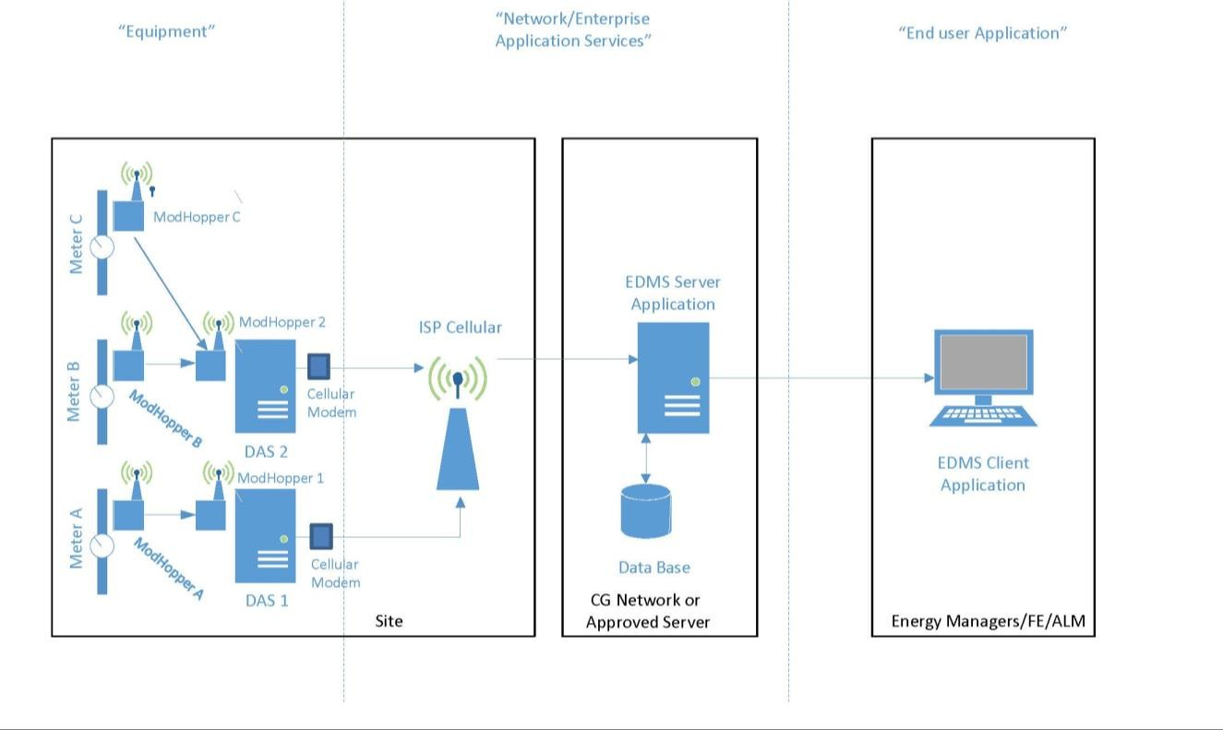
Figure 3: AMI System Diagram

The information gathered by the above systems is collected, analyzed, and archived by an EDMS software tool. While the EDMS is configured through a separate set of prescribed IT documentation, as outlined in Shore Facilities Utilities Metering Guidance Memorandum, the needs of that software both informs and is informed by the configuration standards set for in this Technical Order. As such this section documents the data fields that shall be supported through the selected EDMS. The format of the data feeds into the EDMS shall be in text form via standard delimited text, or XML format per Section 3.2.5.2 DAS requirements.

Key Data Fields

Table 3-1: Electric

Variable | Unit
Energy consumption | kWh
Rate of energy Consumption (Power) | kW
Real Power | kW
Reactive Power | kVAR
Apparent Power | kVA
Power Factor
(Ratio of Real Power/Apparent Power)
Voltage, Line to Line | Volts
Voltage, Line to Neutral | Volts
Current | Amps

Variable | Unit
Average Demand | kW
Minimum Demand | kW
Maximum Demand | kW
Device Number | NUMERIC
Device Type | TEXT
Status | TEXT
Date/Time of last upload | DATE/TIME
Date/Time of last reading | DATE/TIME
Site | TEXT
Sector | TEXT
Location Description | TEXT
Location Number (RPUID) | NUMBER

Table 3-2: Gas

Variable | Unit
Volumetric Consumption | cuft/hour
Gas Ave Rate | cuft/hour
Gas Instantaneous Rate | cuft/hour
Gas Min Rate | cuft/hour
Gas Max | cuft/hour
Device Number | NUMERIC
Device Type | TEXT
Status | TEXT
Date/Time of last upload | DATE/TIME
Date/Time of last reading | DATE/TIME
Site | TEXT
Sector | TEXT
Location Description | TEXT
Location Number | NUMBER

Table 3-3: Water

Variable | Unit
Volumetric Consumption | GPM
Water Average Rate | GPM
Water Instantaneous Flow Rate | GPM
Water Min Rate | GPM
Water Max Flow Rate | GPM
Device Number | NUMERIC
Device Type | TEXT
Status | TEXT
Date/Time of last upload | DATE/TIME
Date/Time of last reading | DATE/TIME
Site | TEXT
Sector | TEXT
Location Description | TEXT
Location Number | NUMBER

    - Recording Intervals
Recording intervals shall conform to latest release of U.S. Department of Energy Metering Best Practices (release 3.0 or later). Recorded time intervals will be 15 minutes to match common utility billing meter intervals, or as otherwise established by SILC. Other user-specified time intervals (e.g., 1 minute, 5 minute), shall be supported for examining system or equipment performance, trending, and start/stop characteristics. The advanced meters shall have the capability to use remote or automated meter reading (AMR).

EXECUTION

Installation and Commissioning
General
    - Prior to the installation of the equipment, the contractor shall provide the Coast Guard with the number of DAS’s, metering devices and transceivers to be installed. Upon receipt of the information, DAS, meter and transceiver device names will be provided by the Coast Guard to the contractor.
    - All equipment shall be installed per manufacturer’s instructions with latest firmware and shall comply with NEC standards, industry specifications and standards and local codes for performance, reliability, compatibility and security (see Technote 88 Security Best Practices - Table 5-3.) The latest installation manuals and best practices for the DAS and Transceivers can be found on the CG AMI Portal – http://CGlink.uscg.mil/AMI or www.obvius.com.
    - Install equipment rigidly and adequately for the operating environment. This includes the use of blocking for support and special fasteners if necessary to ensure tight and secure mounting of equipment. RS485 cable, power cable, and any other wires shall be neatly routed and secured resulting in a neat, orderly appearance. RS485 wiring shall be protected from abrasion upon passing through electrical panel cutout or hole.
    - No wires shall be installed running along/up the exterior façade. All wires shall enter the building and run internally in wall systems or service rooms.
    - All equipment installed to include associated cabling and hardware shall be weather resistant or installed in a weather resistant enclosure per manufacturer’s instructions.
    - Upon final installation, equipment shall not interfere with panel boards or switchgear covers or doors.
    - The contractor shall ensure that the DAS and transceivers are connected to an existing or new 110-120VAC power supply.
    - Programming of the equipment shall be in accordance with the manufacturer’s Installation and Operation Manual. The Coast Guard will provide the contractor with access to the existing DAS as applicable, to obtain the existing ModBus addresses, radio channel, and other pertinent information.
    - DASs, Transceivers and Meters shall be numbered. The numbering scheme shall be in accordance with Appendix F - AMI Equipment Device Naming Convention, and be approved by the Coast Guard prior to installation. Each DAS, I/O Flex Module and transceiver installed shall be physically labeled with the corresponding number.
    - If removal of existing advanced metering components is necessary as part of the scope of work, the Contractor shall reuse existing equipment where possible and return unused equipment to the Facilities Engineer (FE) or Engineering Petty Officer (EPO). Wall finish will be restored to original condition or better (patched and painted to match surrounding finish) for any equipment removed.
    - The Contractor shall arrange for a representative from Obvius, LLC to be on-site for final system configuration as part of any contracts to install metering equipment.

    - The unit shall notify the USCG SILC ESD Energy Branch and MSPL when metering system is installed, updated, or replaced.

Meters
General
- All equipment shall be installed in strict compliance with the manufacturer's instructions and shall include commissioning into the Acquisition Server system.
- The meters supplied shall be integrated into the Coast Guard’s utility monitoring system.
- Meters procured by the contractor must be compatible with the AcquiSuite firmware. (Firmware version v02.15.0226 and newer).
- The meters shall include specifications for any peripherals required.
- Ground exposed, non-current-carrying metallic parts of electrical equipment, metallic raceway systems, grounding conductor in metallic and nonmetallic raceways, telecommunications system grounds, and grounding conductor of nonmetallic sheathed cables, as well as equipment to eliminate shock hazard and to minimize ground loops, common-mode returns, noise pickup, cross talk, and other impairments in accordance with IEEE 1100-2005
Electric
- In situations where panels have a lack of space available or if power entering panel exceeds the capacity of the Standard Configuration (480 VAC, 2400 Amperes), alternate metering solutions that meet the requirements of standard configuration will be considered as follows:
  - Split Core Flexible CTs are encapsulated in silicone rubber allowing for movement when placing in a panel with minimal space. The CT’s are available in both round and rectangular shapes.
  - Flexible Rope CTs have two parts, the flexible coil and compact power and energy meter. The flexible coil is shaped like a rope and fits in extremely tight spaces. The flexible coil is not a self-contained metering unit. The flexible coil is hard-wired into the power and energy meter where it transmits the data to the DAS via a Modhopper Transceiver.
Water
A. Pulse Initiators may be used on existing Utility-owned water meters with prior written consent and assistance by the Local Utility Account Representative. The Contractor shall be responsible for coordinating access to local utility owned assets and notify COR.
Gas
- Installation of gas piping shall be in accordance with ANSI B31.8
- When connecting to existing steel piping systems, provision shall be made to ensure that the integrity of the cathodic protection is not compromised.
- Pulse Initiators may be used on existing Utility-owned gas meters with prior written consent and assistance by the Local Utility Account Representative. The Contractor shall be responsible for coordinating access to local utility owned assets and notify COR.

Data Acquisition Servers (DAS)
- The DAS shall have full administrative capabilities enabled to the unit’s metering lead for initial configuration and for ongoing use of console level metrics.
- For configuration of the DAS: (refer to DAS Manual) http://www.obvius.com
- The check box to allow remote configuration shall be checked on the “LogFileData, Setup/Upload” page (See DAS Manual.)
- A cellular modem shall be installed as part of the DAS installation or add to existing DAS. Contractor or unit shall notify USCG SILC Energy Branch 30 days in advance to request cellular ISP information for connectivity.
  - The DAS shall be connected to cellular modem compatible with the USCG Cellular and Internet Service Provider (ISP) service.
  - If Cellular Service in not available, The DAS shall be configured to dial out land line or POTS (Plain Old Telephone Service) using the ISP phone number and access.
- The Coast Guard unit shall notify SILC Energy Branch it is ready for the interface to the selected EDMS.
- The metering contractor shall verify the new DAS is active on the EDMS website.

Transceivers
- Installation technicians shall ensure unique address for each transceiver, settable via dipswitches on each device, in order to mitigate conflicts and ease troubleshooting efforts. Refer to Appendix F - AMI Equipment Naming Convention Document.
- Installation shall comply with NFPA 70 and NEC.
- Equipment, installation, and wiring shall comply with industry specifications, standards and local codes for performance, reliability, and compatibility.
- Hardwired installations shall use shielded twisted-pair 2 conductor cable compatible with Belden 1120A.
- Installation technicians shall locate transceivers in suitable areas-side or rear facades of buildings if possible, free from large metal plates or sources of radio signals, electrical panels, obstructed locations, thick concrete walls, or areas of high electrical noise.
- Installation technicians shall verify with local facilities personnel the presence of cellular repeaters or Wi-Fi networks.
- Install transceivers as per manufacturer's recommendations and best practices, in order to maximize strength of wireless communication. If the wireless connection between transceivers is weak or intermittent, additional relay transceiver(s) or external antennas shall be installed to facilitate reliable communication.

- Transceivers shall be mounted a minimum of 10 feet away from other radio devices, including other transceivers, cordless phones, and Wi-Fi access points. This minimum is based on typical transmitting power—greater distance may be desired from sources of greater power such as cell phone towers and communication transmitters.
- Transceivers are powered by a 120v wall mounted transformer, and thus shall be mounted close to an available receptacle securely to a wall.

- Transceivers shall not be mounted on metal objects. The antenna of the transceiver must be free and clear of metal beams, conduit, pipes, ducts, etc.
- All transceivers, cables, power cables, and any other wires shall be neatly routed and secured resulting in a neat, orderly appearance.
- Upon establishment of transceivers into a new or existing communications network, each meter bank shall be brought on line sequentially on the transceiver to provide for indications of wiring problems, malfunctioning meters, improper installation, or duplicated addresses. Five minutes minimum shall be provided for the circuit to stabilize prior to troubleshooting.
- Upon establishment of transceivers into a new or existing communications network, there shall be an audit of network addresses to ensure there are no duplicate addresses, between transceivers, or between transceivers and advanced meters.

Submittals
    - The contractor shall provide the following information to the Coast Guard for each metering device installed: CG installation name, the common name of the building, shore tie or equipment being metered, location of installation (to include the electrical panel number and building name and RPUID), size of meter, device number, device address, serial number, location of associated transceiver, device number of associated transceiver, name and location of associated DAS. The contractor shall provide a digital photograph of each set of metering devices after it has been installed in its final location. Multiple devices may be captured in a single photograph if installed within the same location. All information listed above shall be provided to the Mission Support Product Line.

    - The contractor shall provide the following information to the Coast Guard for each DAS, I/O flex module and transceiver device installed: CG installation name, location of installation (to include the building name or number), device number, device address, serial number(or Pulse #), location of power supply, transceiver signal strength (bars), location of external antennas (if applicable). All information listed above shall be provided to the Mission Support Product Line.

    - The contractor shall include the location of metering equipment on electrical and building utility drawings (as applicable for electrical, water and gas meters) submitted as part of the original scope of work.

    - The contractor shall provide a single-line network diagram for each DAS to include each Modbus Device and sizing of each meter (V/AMP, Pipe Dia.) - and provide an As-built drawing of the metering system to include schematic location of metering equipment relative to building and or shore tie. See Appendix E.

    - The contractor shall provide a screenshot of the AcquiSuite route mapping display/Modhopper route map to depict the signal strength between transceivers at the meter and DAS. Procedures are outlined in the manufacturer’s installation and operation manual. The graphic shall depict green lines for communications between transceivers at the meter and DAS indicating good signal strength. Transceiver numbers shall be included in the screenshots. The intent of the screenshot is to verify that the equipment

is properly communicating information at acceptable quality signal strength from each meter to the DAS. See Appendix E.

    - The contractor shall provide a list of advanced metering equipment installed on Excel spreadsheet to include the information as required in 4.2.A and 4.2.B to allow for enrollment of new or modified equipment into the Coast Guard’s Computerized Maintenance Management System (CMMS). See Appendix F All information shall be provided to the Mission Support Product Line in order to ensure all advanced metering equipment is accurately accounted for in the designated CMMS.

    - The contractor shall provide Equipment User Manual for each equipment type installed. http://www.obvius.com

Maintenance
The maintenance procedures below are taken from the US Department of Energy Metering Best Practices: A Guide to Achieving Utility Resource Efficiency, 2015.

Electrical Maintenance
Monthly inspections are required and shall check the integrity of electrical connections in accordance with NFPA 70 and NEC and manufacturer guidance. Annual inspections shall include calibration according to manufacturer’s direction.
Per the CG-43 Shore Facilities Utilities Metering Guidance Memorandum, dated 06 Nov 2014, electrical meters are considered electronics equipment. Proper tracking and accounting of the acquisition, use, and disposal of Coast Guard electronics equipment is required to comply with the Electronics Manual, COMDTINST M10550.25 (series), and Department of Homeland Security and Coast Guard property management policies.

Gas Meter Maintenance
Monthly inspections are required and shall check for the following: gas leaks, noisy operations within the meter, and cleanliness of the equipment. Positive Displacement Meters monthly inspections should look for consistent and smooth register operation. For Differential Pressure Meters monthly inspections check for properly connected and sealed pressure taps. Additionally there shall be an annual inspection which shall include calibration of the meter according to manufacturer's recommendation. Any orifice diameter and edges shall be checked for wear, roughness, or material buildup, all internal surfaces shall be checked to be clean and smooth, and there shall be a check for well-connected and sealed pressure taps. For Velocity Meters, annual inspections shall include a check of the impeller blades and bearings for wear or damage.

Water Meter Maintenance
Monthly inspections are required and shall include an examination of connections for water leakage, unusually loud operations internal to the meter shall be noted, filters or strainers checked for blockage, and general meter cleanliness. Ultrasonic meters shall include checking the transducer positions and attachment to piping, looking at the cleanliness of transducer/piping interface, inspecting the integrity of the sonic coupling fluid between the

transducer and the piping, and verifying piping isolation (i.e., no vibration). Positive displacement meters should be checked for consistent and smooth register operation. Differential pressure meters shall be checked for properly connected and sealed pressure taps. Annual inspections shall include calibration according to manufacturer’s direction. Velocity meters shall include an inspection of the impeller blades and bearings for wear or damage.
Differential pressure meters shall include a check of the orifice diameter and edges for wear, roughness, or material buildup, and a check of the venturi for cleanliness and corrosion at throat.

REFERENCES

Process Relationships
The documents listed in the following tables are referenced or were used to develop standards in this technical order. In order to identify process relationships and potential revisions, applicable documents are identified in the Purpose column as Parent, Sibling, or Child, as described in Figure 5-1.
Process Relationship
Graphical Representation
Revision Potential

If requirements in the parent documents change, this TO may need to be changed
If requirements in the sibling documents change, this TO may need to be changed, and vice versa
Process outputs and subordinate documents generated by this TO
Child
Child
If requirements in this TO change, child documents may need to be changed
Documents that interact with this TO, but are not in a superior or subordinate relationship

Parent

Parent Parent
Superior directives, business processes, and regulatory documents that provide authority or guidance
Sibling
Sibling
THIS
DOCUMENT
SIBLINGS
PARENTS

Figure 4: Process Relationship Descriptions
CHILDREN

Referenced Documents
The following documents are referenced or were used to develop standards in this technical order.
Table 5-1: Coast Guard Publications

Document Name | Document No. | Rev / Date | Purpose
Civil Engineering Manual | COMDTINST M11000.11 | Series | (Parent) Establishes framework for the CE program
Shore Facilities Utilities Metering Guidance Memorandum |  | 06 Nov  2014 | (Parent) CG-43 Memorandum
Shore Infrastructure – Mission Support Business Model RDTO | SILC-RDTO-36- 11 29 11 00-01 | Latest | (Parent) Authority for creating SILC technical orders to further define the MSBM
Safety and Environmental Health Manual | COMDTINST M5100.47 | Series | (Parent) Defines safety requirements for working with Electrical Utilities
EISA Audit Covered Facilities List |  |  | Defines Facilities which are required to be included in the Energy Audits- High Energy Usage 75% of USCG Energy Usage

Table 5-2: Other Government Publications

Document Name | Document No. | Rev / Date | Purpose
Energy Independence and Security Act of 2007 | EISA 2007 | 2007 | Provides high level requirements
Energy Policy Act of 2005 | EPAct 2005 | 2005 | Provides high level requirements
FEMP O&M Best Practices: A Guide to Achieving Operational Efficiency |  | Release 3.0 | Provides high level requirements and best practices
U.S. Department of Homeland Security Metering Plan |  | November 2015 | Provides high level requirements
USDOE Metering Best Practices: A Guide to Achieving Utility Resource Efficiency |  | 2015  Release 3.0 | Provides high level requirements and best practices

Table 5-3: Technical Publications

Document Name | Document No. | Rev / Date | Purpose
AcquiSuite – Data Acquisition Server Obvius, LLC  www.obvius.com | Model A8812 | Aug 16,  2011 | Installation and Operation Manual
Modhopper – Wireless ModBus/Pulse Transceiver Obvius, LLC  www.obvius.com | Model R9120 | Rev C/ Apr 04  2016 | Installation and Operation Manual
Security Best Practices for AcquiSuite  Obvius, LLC www.obvius.com | Technote 88 | Oct 11,  2016 | Best Practice Guide

    - Supporting Documents

      - American National Standards Institute / American Society of Mechanical Engineers (ANSI/ASME) B31.8, 2016, Gas Transmission and Distribution Piping Systems
      - Coast Guard Commandant Instruction (COMDTINST) M5500.13E, August 2015,
      - Cybersecurity Manual
      - Institute of Electrical and Electronics Engineers (IEEE) C37.90.1, 2012, Standard for Surge Withstand Capability (SWC) Tests for Relays and Relay Systems Associated with Electric Power Apparatus
      - Institute of Electrical and Electronics Engineers (IEEE) 1100-2005, 2006, Recommended Practice for Powering and Grounding Electronic Equipment (ANSI)
      - National Institute of Standards and Technology’s (NIST) Special Publication (SP) 800- 171, “Protecting Controlled Unclassified Information in Nonfederal Information Systems and Organization

DEFINITIONS

See the Shore Infrastructure Lexicon for common glossary terms. Table 6-1 lists key terms that are important for understanding this technical order. Table 6-2 lists acronyms and abbreviations that are used in this document.
Table 6-1: Key Terms

Term | Definition
Advanced metering device | A separate electronic device coupled to a standard meter or to a building automation system that enables it to function as an advanced meter.
Advanced metering system | A system that collects time-differentiated energy or water usage data from advanced meters via a network system on either an on-request or defined schedule basis. The system is capable of providing usage information on at least a daily basis and can support desired features and functionality related to energy-use management, procurement, and operations.
Advanced meters | An advanced meter records energy or water consumption data hourly or more frequently and provides for daily or more frequent transmittal of measurements over a communication network to a central collection point. Features of advanced meters vary depending on the utility they are serving.
Amperes (amps, A) | The measure of electric current flow in a conductor and usually measured with an ammeter or current transformer. Some electrical equipment, such as wire size or circuit breaker size, is rated by its maximum capacity to safely handle electrical current.
Appropriate | The installation of standard meters or advanced meters is “appropriate” in all Federal buildings that are not excluded from metering within the 2014 Federal Building Metering Guidance
Benchmarking System | A tool, or system of tools, that enables the performance of a metered building to be benchmarked. ENERGY STAR Portfolio Manager is the designated building energy use benchmarking system for fulfilling Federal benchmarking requirements.
British thermal unit (Btu) | A commonly used unit of energy, especially for fuels or heat. A kilowatt hour is equal to approximately 3412 Btu. Quantity of heat required to raise 1 pound of water by 1°F, close to the equivalent amount of energy generated by burning a kitchen match.
Covered Facility | A facility that an agency has designated as subject to the requirements of section 432 of the Energy Independence and Security Act of 2007 (Pub. L. No. 110-140, as codified at 42 U.S.C. § 8253(f)). This requires agencies to designate covered facilities comprising at least 75 percent of their total facility energy use. A covered facility may be defined as a group of facilities at a single location or multiple locations managed as an integrated operation. A covered facility may also be a single building, if so identified by the agency.

Term | Definition
Demand | A measure of the average real power consumption over a specified time interval. The rate at which electricity is delivered by a system or part of a system, or to a load point or set of loads. It is measured in kilowatts, kilovolt amperes, or other suitable unit at a given instant or averaged over a designated period of time. Depending on the utility, the specified demand interval will be between 5 minutes and 1 hour. A 15-minute demand interval is the most common used in the United States, while a 30-minute demand interval is more common in Europe.
Frequency Hopping Spread Spectrum (FHSS) | A method of transmitting radio signals by switching a carrier among numerous frequency channels, using a random sequence known to transmitter and receiver.
Kilowatt-hour (kWh) | A standard unit of energy equivalent to 1,000 watts over 1 hour.
Load aggregation | Aggregation of energy consumption from facilities that is geographically separate from each other for purposes of acquiring and billing utility services.
MODBUS | Modbus is a communication protocol used for transmitting information over serial lines between electronic devices. The device requesting the information is called the Modbus Master (DAS) and the devices supplying information are Modbus Devices (Meters and Modhoppers).
NEMA standards | Property characteristics adopted as standard by the National Electrical Manufacturers Association.
Remote Terminal Unit(RTU) | A microprocessor-controlled electronic device that interfaces objects in the physical world to a distributed control system or SCADA (supervisory control and data acquisition) system by transmitting telemetry data to a master system,
Standard meters | Electromechanical or solid state meters that cumulatively measure, record, and store aggregated usage data that are periodically retrieved for use in customer billing or energy management. Meters that are not advanced meters are standard meters.
Sub-metering | Separation of energy consumption from facilities that is geographically separate from each other for the purpose of acquiring energy consumption data (distribution of loads) among buildings within a facility (campus).
Voltage (volts, V): | The measure of electric potential between two points in a circuit and typically measured with a voltmeter or potential transformer. Voltage may be expressed in terms of line-to-neutral (L-N) for a two-wire system or line-to- line (L-L) for a multi-wire system.
Volt-amperes (volt- amps, VA): | The measure of “apparent” power, or rate of energy, supplied to an electric load. The volt-ampere (designated VA) can be determined by the voltage multiplied by the current. The volt-ampere is frequently the metric used to rate the capacity of electrical equipment, such as transformers or switchgear.
Watt | A measure of power, or rate of energy flow, delivered to an electric load. The rate of energy transfer equivalent to 1 ampere flowing under a pressure of 1 volt at unity power factor. Power can be measured instantaneously (kW) or averaged over time (kWh/h). Average time interval power will also satisfy the time interval data required to be metered and recorded by EPAct 2005.

Table 6-2: Acronyms and Abbreviations

Term | Definition
AES | Advanced Encryption Standard
ALM | Asset Line Manager
AMI | Advanced Metering Initiative
AMR | Automated Meter Reading
ARRA | American Reinvestment and Recovery Act of 2009
BOD | Business Operations Division
CATCODES | Category Codes
CCF | Hundred cubic feet.
CMMS | Computerized Maintenance Management System
CEU | Civil Engineering Unit
CIVW | Civil Works
COMDTINST | USCG Commandant Instruction
CSTO | Configuration Standard Technical Order
CT | Current Transformer
DAS | Data Acquisition Server
EAM | Electric Advanced Meter
ECM | Energy Conservation Measure
EDMS | Energy Data Management System
EISA 2007 | Energy Independence and Security Act of 2007
EO | Executive Order
EPAct | Energy Policy Act of 2005
EPO | Engineer Petty Officers
ESD | Engineering Services Division
ESPC | Energy Savings Performance Contracts
FD&CC | Facilities Design & Construction Center
FE | Facility Engineers
FEMP | Federal Energy Management Program
FHSS | Frequency Hopping Spread Spectrum
GAM | Gas Advanced Meter
IOM | I/O Flex Module
ISP | Internet Service Provider

Term | Definition
J&A | Justification and Accountability
MSPL | Mission Support Product Line
NEC | National Electrical Code
NEMA | National Electrical Manufacturers Association
NFPA | National Fire Protection Association
NIST | National Institute of Standards and Technology
PGTO | Process Guide Technical Order
RTU | Remote Terminal Unit
RPUID | Real Property Unique Identifier
SILC | Shore Infrastructure Logistics Center
SOVT | System Operational Verification Test
UESC | Utility Energy Service Contracts
USCG | United States Coast Guard
WAM | Water Advanced Meter
XCVR | Tranceiver
XML | Extensible Markup Language

Appendix A – Business Case Analysis

Deviations from or additions to Federal, DHS, or Coast Guard guidance for the qualification or prioritization of advanced metering shall use the following procedures. Per Shore Facilities Utilities Metering Guidance Memorandum, cost effectiveness of metering will use 10 year simple payback, assuming 2% or higher savings on the use of the metered data. This can be calculated per Federal Energy Management Program’s O&M Best Practices: A Guide to Achieving Operational Efficiency as follows:

( 𝐼𝑛𝑠𝑡𝑎𝑙𝑙𝑒𝑑 𝐶𝑜𝑠𝑡
[
𝐷𝑒𝑠𝑖𝑟𝑒𝑑 𝑆𝑖𝑚𝑝𝑙𝑒 𝑃𝑎𝑦𝑏𝑎𝑐𝑘

) + 𝐴𝑛𝑛𝑢𝑎𝑙 𝐶𝑜𝑠𝑡]

= 𝑀𝑖𝑛𝑖𝑚𝑢𝑚 𝐴𝑛𝑛𝑢𝑎𝑙 𝐸𝑙𝑒𝑐𝑡𝑟𝑖𝑐 𝐵𝑖𝑙𝑙

Where:
% 𝐴𝑛𝑛𝑢𝑎𝑙 𝑆𝑎𝑣𝑖𝑛𝑔𝑠

Installed Cost refers to the total cost to purchase, install, and commission the meter. As previously noted, the cost of a meter application will vary based on a number of factors. Building electric meters are often in the range of $1,000 to $5,000 completely installed. This broad range reflects the uncertainty of system upgrades that may be associated with electrical code compliance issues.
Desired Simple Payback represents the number of years it will take the metering system to produce (lead to) cost savings equal to the installed cost. Most agencies prefer a simple payback period of 10 years or less.
Annual Cost is the total annual cost of the fees and expenses to cover communications, data collection and storage, and data analysis, as well as meter operations and maintenance. The annual cost will vary based on several factors and is typically in the range of $120/year ($10/ month) to $600/year ($50/month).
% Annual Savings is the estimated cost savings benefits to be realized from the productive use of the metered data. Federal sites are advised to use a minimum of 2 percent annual savings when considering meters for EPAct 2005 compliance.
Minimum Annual Electric Bill in the above formula requires that there be a reasonable way to estimate the current annual electricity (utility) costs for the building being considered. Except in cases where the buildings already have standard meters, actual usage data to estimate the annual costs will not be available. In these cases, one of the following accepted methods of estimating building energy use should be applied (see Metering Best Practices: A Guide to Achieving Utility Resource Efficiency DOE/EE-0323).
- Square footage.
- Energy-use intensity.
- Calibrated software.
- Short-term metering.

Appendix B – Data Acquisition Server (DAS) Specifications

AcquiSuite A8812-1 and A8812-GSM

Specifications
Processor | ARM9 embedded CPU, ARM7 IO co-processor
Operating System | Linux 2.6
Memory | 32 MB RAM
Flash ROM | 16 MB NOR Flash (expandable with USB memory device)
Interval Recording | 1 to 60 minutes, user selectable
LEDs | 8x input, 4 modem activity, Modbus TX/RX, power, system, IO status
Console | 2 x 16 LCD character, two push buttons
Power
North America | 110-120VAC, 60Hz, primary
CE/Europe | 100-240VAC, 50-60Hz, primary (interchangeable plug adapters optional)
Power Supply | 24VDC, 1A, class 2 wall brick transformer included
Communication
Protocols | Modbus/RTU, Modbus/TCP, TCP/IP, PPP, HTTP/HTML, FTP, NTP, XML, SNMP-Trap
LAN | RJ45 10/100 Ethernet, full half duplex, auto polarity
Modem | V.34 bis, 33,600 bps (A8812-1 only)
Cellular | GSM/GPRS Cellular (A8812-GSM only)
USB | USB expansion port
Inputs
Serial Port | RS-485 Modbus, supports up to 32 external devices (expandable)
I/O | 8x Flex IO inputs with user selectable modes: voltage, current, resistance, pulse and status
Outputs
Relays | 2x, dry contact 30 VDC, 150 mA max
Physical
Weight | 5lbs (2.3kg)
Size | 8" x 9.25" x 2.5" (203mm x 235mm x 64mm)
Environment
North America | 0 to 50C, 0-90% RH, non-condensing
CE/Europe | 5 to 40C, 0-90% RH, non-condensing
Codes and Standards
FCC CFR 47 Part 15, Class A, EN 61000, EN 61326, CE
NEMA enclosures available

Appendix C – Wireless ModBus/Pulse Transceiver

Specifications
Processor | 60MHz ARM7 embedded CPU
LEDs | 3 x RF, 2 x RS-485, 2 x Pulse, Alive, Alarm
Designed specifically for wireless metering 256Bit AES, FIPS-197 certified, J/F-12 8306 No software or programming required
Devices automatically configure when powered Wireless “mesh” network self-healing, self-optimizing Frequency hopping, spread spectrum (FHSS)
Connect up to 32 Modbus and 2 pulse devices per ModHopper (expandable) Long distance communication (3000ft indoor / 14 miles LOS)
Visual display of signal strength (LEDs) Multiple independent network capability
Reliable, constant two-way communication and packet verification Point to multi-point communication
Field upgradable firmware
Power
North America | 110-120VAC, 60Hz, primary, 9-12VDC class 2 power supply included
CE/Europe | 100-240VAC, 50-60Hz, primary (power supply not included)
Power Supply | R9120-5T 9-30VDC, 900mA Required
Communication
Protocols | Modbus RTU, 2-wire
R9120-5 | 900MHz, 1W, 3000ft (900m) indoor, 14 miles (22km) line of sight
Baud Rate | 9600/19200 baud, N, 8, 1
Addressing | Modbus address may be set from 1 to 247 via dipswitch
RF | Frequency hopping, spread spectrum (FHSS), ISM band (see table)
I/O
I/O 2x Pulse, dry contact, standard or KYZ, closure threshold 100Ω to 2.5Ω user selectable Pulse Rate User selectable to 10Hz, 50Hz, 100Hz, 250Hz
- Pulse rate option 10Hz, minimum pulse width 50ms
- Pulse rate option 50Hz, minimum pulse width 10ms
- Pulse rate option 100Hz, minimum pulse width 5ms
- Pulse rate option 250Hz, minimum pulse width 2ms Storage Pulse counts stored in non-volatile memory
ModBus RTU, 2-wire, hard-wire connect up to 32 devices (expandable)
Physical
Weight | 1.25lbs (0.67 kg)
Size | 6.5" x 4.5" x 2" (260mm x 64mm x 45mm)
Environment

North America | -30 to 70C, 0-90% RH, non-condensing (-T version only, R9120- 5T)  0 to 50C, 0-90% RH, non-condensing
CE/Europe | 5 to 40C, 0-90% RH, non-condensing
Altitude | 2000M max
Pollution | Degree 2
Codes and Standards
FCC ID OUR-9XTEND
IC (Industry Canada) IC 4214A-9XTEND; FCC CFR 47 Part 15, Class A
NEMA enclosures available

Appendix D – SAMPLE Justification and Accountability (J&A)

Pursuant to the requirements of the Competition in Contracting Act (CICA) as implemented by the Federal Acquisition Regulation (FAR) Subpart 6.3 and in accordance with the requirements of FAR 6.303-1, the justification for the use of the statutory authority under FAR Subpart 6.3 is justified by the following facts and rationale required under FAR 6.303-2 as follows:
- Agency and Contracting Activity - DHS, U.S. Coast Guard, Formal Contracts Division VII, CG-9127 proposes to enter into a contract on the basis of other than full and open competition and presents this Justification and Approval for Other Than Full and Open Competition (J&A) for review and approval.
- Nature and/or Description of Action being Approved – Approval is requested to solicit, on a sole-source basis, procurement of a data acquisition server, specifically AcquiSuite, listed in paragraph three (3) of this J&A and Section 2.2.5.3 of the Advanced Metering Infrastructure Configuration Standard Technical Order (AMI CSTO) for Advanced Metering Systems. The proposed vendor is Obvius, LLC 3300 NW 211th Terrace Hillsboro, OR 97124.
A firm-fixed price contract is anticipated, with an estimate of $XX.XX ea, using Operations and Maintenance funds. In accordance with the USCG Component of the DHS Metering Plan, it is anticipated that in the next 5 years approximately 300 AcquiSuites will be installed for an estimated total of $XX.XX.
- Description of Supplies/Services – This requirement is to provide Obvius AcquiSuite Data Acquisition Servers as part of the Advanced Metering Infrastructure Equipment Components.
The purpose of this Justification is to provide for the continued advanced metering system operation for existing and new systems by ensuring metering equipment compatibility and interoperability with the Coast Guard Network- CGOneNET.
The Coast Guard Utility Advanced Metering infrastructure is based on and requires to be compatible with the USCG approved Data Acquisition Server (DAS) AcquiSuite by Obvius, LLC which collects data from advanced meters that support existing electric and water meters but also support gas and steam utilities, thereby allowing the Coast Guard to incorporate all utilities into an utilities enterprise monitoring system.
Obvius, LLC is the only source qualified to fulfill this requirement.

AcquiSuite – Data Acquisition Server – Model A8812 – Manufactured by Obvius, LLC

- Identification of Statutory Authority Permitting Other than Full and Open Competition – The statutory authority permitting other than full and open competition is 10 USC 2304 (c)(1)(for USCG) or 41 U>S>C.3304(a)(1)(for other Components) implemented for the FAR Subpart 6.302-1 entitled ;only One Responsible Source and No Other Supplies or Services will Satisfy Agency Requirements.” This justification is applicable and limited to specifically the item described above. This justification is limited to the OEM or OEM approved source. Obvius, LLC is the OEM for this item and the only known source of supply.

- Demonstration that the Nature of the Acquisition Requires Use of the Authority cited

The advanced metering project was originally an unfunded Congressional Mandate to measure the electrical consumption at the building level instead of the base level, which we currently track through the FINCEN utility invoicing system. In 2010, the Coast Guard received from the American Recovery and Reinvestment Act of 2009 (ARRA) funding to accomplish the procurement and installation of the equipment. In 2011, it was discovered that the process had not been initiated to connect the equipment and store the data on the CGOneNET. Therefore, MSPL (Mission Support Product Line) in coordination with CG-46 (CG Energy Office), CG-43 (CG Office of Civil Engineering), and SILC (Shore Infrastructure Logistic Center) were required to have equipment tested as part of the USCG Component Security Assessment. In September 2012, the equipment–specifically, the Obvius-AcquiSuite Model A8812– Data Acquisition Server (DAS) was tested in a lab environment to determine any security vulnerabilities.

A Retina Network security scan of the AMI system was performed and completed on 10/31/2012 A CGONE/SIPRNET Enterprise Hardware Technical Evaluation Report was completed on 12/12/2012.
1- Retina Network Security Scanner, Network Vulnerability Assessment and Remediation Management of 31 Oct 2012.

CGONE/SIPRNET Enterprise Hardware Technical Evaluation Report for AcquiSuite Server – Advanced Metering Infrastructure of 12 Dec 2012.

Based on the above testing and security scan approvals, the Obvius, LLC proprietary AcquiSuite Data Acquisition Server is required to provide compatibility with existing units and ensures interface with CGOneNET.

In addition to the Energy Policy Act (EPAct) of 2005 and the Energy Independence and Security Act (EISA) of 2007, and the more recent publication of the Dept. of Energy FEMP Utility Metering Guidance 2014 requires all Federal Agencies to install electric, water and gas advanced metering at appropriate federal facilities.

The Advanced Metering Infrastructure (AMI) project utilizing the Obvius AcquiSuite Data Acquisition Server will provide a fully functional, utility metering system at over 220 Coast Guard units, encompassing over 1,300 buildings and housing units, and over 200 cutter shore ties.
This will satisfy the federal government mandates and enable the Coast Guard to monitor total energy. Obvius DAS is the only AMI Component device approved to safely operate on CGOneNET. Other devices would entail a significant effort for the process of gaining access to the CG server, cost for analysis, testing and approvals.
- Description of Efforts made to ensure that Offers are solicited from as Many Potential Sources as is Practicable – This action does not meet the dollar threshold for a FedBizOpps posting. Award to any other source would result in unacceptable delays in fulfilling the Federal Energy Mandate requirements and substantial duplication of cost to the Government that is not expected to be recovered through competition.
The DAS Units were initially accepted under the Lowest Price Technically Acceptable (LPTA) ARRA Funded Project in 2012 which was a solicitation of competitive bids. Projects will be

completed as appropriate and this product will be a Sole Source construction material under a construction contract or units will be purchased directly for unit installation.
- Determination by the Contracting Officer that the Anticipated Cost to the Government will be Fair and Reasonable - This acquisition is limited to the OEM or OEM approved source. Obvius LLC is the OEM for this component and the only known source of supply. Any other potential offeror would have to provide necessary certifications to ensure the server is compatible and approved for connection and operability on U.S. Coast Guard Network. It is the Contracting Officer's opinion that prices ultimately negotiated for this procurement will be fair and reasonable based on a comparison to commercial prices, a comparison to historical pricing information on similar items. The Contracting Officer determines that the anticipated price will be fair and reasonable based on the competitive market price for this product, and prior acquisition history.
As stated above, this justification applies to only one brand name construction products, not to the entire project. Price reasonableness will be documented in the contract file.
- Description of Market Research - This product was proposed under the original AMI Solicitation and resulting contract, vendor proposed, and government accepted. Product market research was conducted using Internet search engines, manufacturer’s catalogs, and construction references at the time of the original contract in 2012.
- Any Other Facts Supporting the Use of Other Than Full & Open Competition - As Stated in Paragraph five (5) of the J&A, any other potential offeror would have to provide the necessary testing approvals. Competition among vendors other than Obvius would result in unnecessary cost to the government. To use other vendors would require the Coast Guard to complete extensive testing to certify that the data acquisition server can safely operate on CGOneNET and be compatible with the metering infrastructure in the legacy AMI system. This substantial cost and program delays to the Government is not expected to be recovered through competition and it would also cause unacceptable delays in fulfilling immediate Coast Guard mission requirements in meeting Federal Energy Mandates.

- A Listing of Sources, if any, that Expressed, in Writing, an Interest in the Acquisition - Not Applicable.
- A Statement of the Actions, if any, the Agency May Take to Remove or Overcome any Barriers to Competition Before any Subsequent Acquisition for Supplies or Services Required - The DAS component specified in this document and referenced AMI CSTO is required to enable compatibility with existing systems and future advanced metering systems installation and meet Federal mandates for utilities consumption and reporting requirements. Until such time as technological advances, changes in Federally Mandated requirements or USCG mission requirements shall this specific component- the Obvius AcquiSuite DAS be altered whereby the Agency may remove or overcome the this barrier to competition.
- Contracting Officer’s Certification. I certify that the data supporting the recommended use of other than full and open competition is accurate and complete to the best of my knowledge and belief.

Contracting Officer Date

- Technical/Requirements Personnel Certification. I certify this requirement meets the Government’s minimum need and that the supporting data, which forms a basis for this justification, is complete and accurate.

Technical Representative Date

APPROVAL:

Contracting Officer * Date
*Note: KO approves: (1) when action does not exceed $650K; and (2) when, regardless of dollar amount, the contract is awarded under FAR 6.302-7, Public Interest.

Command Procurement Activity Date Competition Advocate (CPACA)**
**Note: CPACA approves: (1) when action exceeds $650K but is less than or equal to $12.5M; and when, regardless of dollar amount, the contract is awarded under FAR 6.302-7, Public Interest.

Procuring Activity Competition Date Advocate (PACA)***
***Note: PACA approves: (1) when action exceeds $12.M but is less than or equal to $85.5M and when, regardless of dollar amount, the contract is awarded under FAR 6.302-7, Public Interest.

DHS Chief Procurement Officer**** Date
****Note: CPO approves: (1) when action exceeds $85.5M and when, regardless of dollar amount, the contract is awarded under FAR 6.302-7, Public Interest.

Appendix E – Sample Statement of Work

SAMPLE - Advanced Metering Scope of Work
Intent
The intent of the advanced metering scope of work is to capture the energy and water consumption of buildings and vessels throughout the Coast Guard. The focus is to meter facilities at the individual building level and to measure the energy and water consumption of cutters connected to their shore ties while in port. This effort also satisfies the Coast Guard’s obligation to meet requirements mandated as part of the Energy Policy Act (EPAct) of 2005, and the Energy Independence and Security Act (EISA) of 2007.
Requirements
  - All Advanced Metering equipment shall be in accordance with the USCG Advanced Metering Infrastructure Configuration Standard Technical Order (AMI CSTO) (servers, I/O flex modules, modems, wireless transceivers, electric, gas and water meters, etc.) All AMI equipment installed shall be fully compatible with the Data Acquisition Server (DAS) Model A8812. Wireless transceivers, called Modhoppers shall be Model 9120-5 (256 bit AES encryption technology), manufactured by Obvius, LLC or equivalent.
  - All equipment installed to include associated cabling and hardware shall be weather resistant or installed in a weather resistant NEMA-rated enclosure per manufacturer’s instructions.
  - All equipment shall be installed per manufacturer’s instructions with latest firmware and shall comply with NEC standards, industry specifications and standards and local codes for performance, reliability, and compatibility and security (see Technote 88 Security
Best Practices - Table 5-3 of AMI CSTO.) The latest installation manuals and best practices for the DAS and transceivers can be found on the CG AMI Portal – http://CGlink.uscg.mil/AMI or www.obvius.com.
  - Prior to the installation of the equipment, the contractor shall provide the Coast Guard with the number of DAS’s, metering devices and transceivers to be installed. Upon receipt of the information, DAS, meter and transceiver device names will be provided by the Coast Guard to the contractor.
  - Install equipment rigidly and adequately for the operating environment. This includes the use of blocking for support and special fasteners if necessary to ensure tight and secure mounting of equipment. RS485 cable, power cable, and any other wires shall be neatly routed and secured resulting in a neat, orderly appearance. RS485 wiring shall be protected from abrasion upon passing through electrical panel cutout or hole.
  - No wires shall be installed running along/up the exterior façade. All wires shall enter the building and run internally in wall systems or service rooms.
  - All Cables to be continuous with no cable splices.
  - Install transceivers as per manufacturer's recommendations and best practices-side or rear facades of buildings if possible, in order to maximize strength of wireless communication. If the wireless connection between transceivers is weak or intermittent, additional relay transceiver(s) or external antennas shall be installed to facilitate reliable communication.
  - If remote or external Antenna is required, the location shall be line of site with continuous cable. The type of Antenna shall be designed for outdoor use and most extreme weather conditions.

  - Upon final installation, equipment shall not interfere with the panel board or switchgear covers or doors.
  - The contractor shall ensure that the DAS and transceivers are connected to an existing or new 110-120VAC power supply.
  - The Coast Guard will provide diagrams and drawings of the current metering system installed throughout the facility.
  - Programming of the equipment shall be in accordance with the manufacturer’s Installation and Operation Manual. The Coast Guard will provide the contractor with access to the existing DAS to obtain the existing Modbus addresses, radio channel, and other pertinent information.
  - A cellular modem shall be installed as part of the DAS installation or add to existing DAS. Contractor or unit shall notify USCG SILC Energy Branch 30 days in advance to request cellular ISP information for connectivity.
    - The DAS shall be connected to cellular modem compatible with the USCG Cellular and Internet Service Provider (ISP) service.
    - If Cellular Service in not available, the DAS shall be configured to dial out land line or POTS (Plain Old Telephone Service) using the ISP phone number and access.
  - DASs and Transceivers shall be numbered. The numbering scheme shall be in accordance with the AMI Equipment Device Naming Convention - (AMI CSTO-Appx F) and be approved by the Coast Guard prior to installation. Each DAS, I/O Flex Module and Transceiver installed shall be physically labeled with the corresponding number.
  - If removal of existing advanced metering components is necessary as part of the scope of work, the Contractor shall reuse existing equipment where possible and return unused equipment to the Facilities Engineer (FE) or Engineering Petty Officer (EPO). Wall finish will be restored to original condition or better (patched and painted to match surrounding finish) for any equipment removed.
  - The Contractor shall arrange for a representative from Obvius, LLC to be on-site for final system configuration as part of any contracts to install metering equipment.
  - Meters General
    - All equipment shall be installed in strict compliance with the manufacturer's instructions and shall include commissioning into the Acquisition Server system.
    - The meters supplied shall be integrated into the Coast Guard’s utility monitoring system.
    - Meters procured by the contractor must be compatible with the AcquiSuite firmware. (Firmware version v02.15.0226 and newer).
    - The meters shall include specifications for any peripherals required.
    - Ground exposed, non-current-carrying metallic parts of electrical equipment, metallic raceway systems, grounding conductor in metallic and nonmetallic raceways, telecommunications system grounds, and grounding conductor of nonmetallic sheathed cables, as well as equipment to eliminate shock hazard and to minimize ground loops, common-mode returns, noise pickup, cross talk, and other impairments in accordance with IEEE 1100-2005

  - Electric
    - In situations where panels have a lack of space available or if power entering panel exceeds the capacity of the Standard Configuration (480 VAC, 2400 Amperes), alternate metering solutions that meet the requirements of standard configuration will be considered as follows:
    - 1. Split Core Flexible CTs are encapsulated in silicone rubber allowing for movement when placing in a panel with minimal space. The CT’s are available in both round and rectangular shapes.
    - 2. Flexible Rope CTs have two parts, the flexible coil and compact power and energy meter. The flexible coil is shaped like a rope and fits in extremely tight spaces. The flexible coil is not a self-contained metering unit. The flexible coil is hard-wired into the power and energy meter where it transmits the data to the DAS via a Modhopper Transceiver.

  - Water
    - Pulse Initiators may be used on existing Utility-owned water meters with prior written consent and assistance by the Local Utility Account Representative. The Contractor shall be responsible for coordinating access to local utility owned assets and notify COR.

  - Gas
    - Installation of gas piping shall be in accordance with ANSI B31.8
    - When connecting to existing steel piping systems, provision shall be made to ensure that the integrity of the cathodic protection is not compromised.
    - Pulse Initiators may be used on existing Utility-owned gas meters with prior written consent and assistance by the Local Utility Account Representative. The Contractor shall be responsible for coordinating access to local utility owned assets and notify COR.

  - Data Acquisition Servers (DAS)
    - The DAS shall have full administrative capabilities enabled to the unit’s metering lead for initial configuration and for ongoing use of console level metrics.
    - For configuration of the DAS: (refer to DAS Manual) http://www.obvius.com
    - The check box to allow remote configuration shall be checked on the “LogFileData, Setup/Upload” page (See DAS Manual.)
    - A cellular modem shall be installed as part of the DAS installation or add to existing DAS. Contractor or unit shall notify USCG SILC Energy Branch 30 days in advance to request cellular ISP information for connectivity.
    - The DAS shall be connected to cellular modem compatible with the USCG Cellular and Internet Service Provider (ISP) service.
    - If Cellular Service in not available, The DAS shall be configured to dial out land line or POTS (Plain Old Telephone Service) using the ISP phone number and access.
    - The Coast Guard unit shall notify SILC Energy Branch it is ready for the interface to the selected EDMS.
    - The metering contractor shall verify the new DAS is active on the EDMS website.
  - Transceivers
    - Installation technicians shall ensure unique address for each transceiver, settable via dipswitches on each device, in order to mitigate conflicts and ease

troubleshooting efforts. Refer to Appendix F - AMI Equipment Naming Convention Document.
    - Installation shall comply with NFPA 70 and NEC.
    - Equipment, installation, and wiring shall comply with industry specifications, standards and local codes for performance, reliability, and compatibility.
    - Hardwired installations shall use shielded twisted-pair 2 conductor cable compatible with Belden 1120A.
    - Installation technicians shall locate transceivers in suitable areas-side or rear facades of buildings if possible, free from large metal plates or sources of radio signals, electrical panels, obstructed locations, thick concrete walls, or areas of high electrical noise.
    - Installation technicians shall verify with local facilities personnel the presence of cellular repeaters or Wi-Fi networks.
    - Install transceivers as per manufacturer's recommendations and best practices, in order to maximize strength of wireless communication. If the wireless connection between transceivers is weak or intermittent, additional relay transceiver(s) or external antennas shall be installed to facilitate reliable communication.
    - Transceivers shall be mounted a minimum of 10 feet away from other radio devices, including other transceivers, cordless phones, and Wi-Fi access points. This minimum is based on typical transmitting power—greater distance may be desired from sources of greater power such as cell phone towers and communication transmitters.
    - Transceivers are powered by a 120v wall mounted transformer, and thus shall be mounted close to an available receptacle securely to a wall.
    - Transceivers shall not be mounted on metal objects. The antenna of the transceiver must be free and clear of metal beams, conduit, pipes, ducts, etc.
    - All transceivers, cables, power cables, and any other wires shall be neatly routed and secured resulting in a neat, orderly appearance.
    - Upon establishment of transceivers into a new or existing communications network, each meter bank shall be brought on line sequentially on the transceiver to provide for indications of wiring problems, malfunctioning meters, improper installation, or duplicated addresses. Five minutes minimum shall be provided for the circuit to stabilize prior to troubleshooting.
    - Upon establishment of transceivers into a new or existing communications network, there shall be an audit of network addresses to ensure there are no duplicate addresses, between transceivers, or between transceivers and advanced meters.

Submittals

  - The contractor shall provide a screenshot of the AcquiSuite route mapping display/Modhopper route map to depict the signal strength between transceivers at the meter and DAS. Procedures are outlined in the manufacturer’s installation and operation manual. The graphic shall depict green lines for communications between transceivers at the meter and DAS indicating good signal strength. Transceiver numbers shall be included in the screenshots. The intent of the screenshot is to verify that the equipment is properly communicating information at acceptable quality signal strength from each meter to the DAS.

  - The contractor shall provide the following information to the Coast Guard for each metering device installed: CG installation name, the common name of the building, shore tie or equipment being metered, location of installation (to include the electrical panel number and building or Asset name and RPUID), size of meter, device number, device address, serial number, location of associated transceiver, device number of associated transceiver, name and location of associated DAS. The contractor shall provide a digital photograph of each set of metering devices after it has been installed in its final location. Multiple devices may be captured in a single photograph if installed within the same location.
  - The contractor shall provide the following information to the Coast Guard for each DAS, I/O flex module and transceiver device installed: CG installation name, location of installation (to include the building name or number), device number, device address, serial number(or Pulse #), location of power supply, transceiver signal strength (bars), location of external antennas (if applicable).
  - The contractor shall include the location of metering equipment on electrical and building
utility drawings (as applicable for electrical, water and gas meters) submitted as part of the original scope of work.
  - The contractor shall provide a single-line network diagram for each DAS to include each Modbus Device and sizing of each meter (V/AMP, Pipe Dia.) and provide an As-built drawing of the metering system to include schematic location of metering equipment relative to building and or shore tie.
  - The contractor shall complete the CG Equipment Enrollment Spreadsheet of all advanced metering equipment installed to include the information as required to allow for enrollment of new or modified equipment into the CG’s Computerized Maintenance Management System (CMMS).
  - The contractor shall provide Equipment User Manual for each equipment type installed. http://www.obvius.com

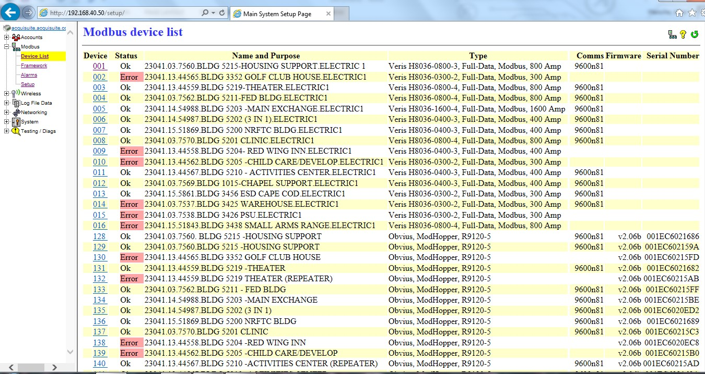
Figure 1- ModBus Device List
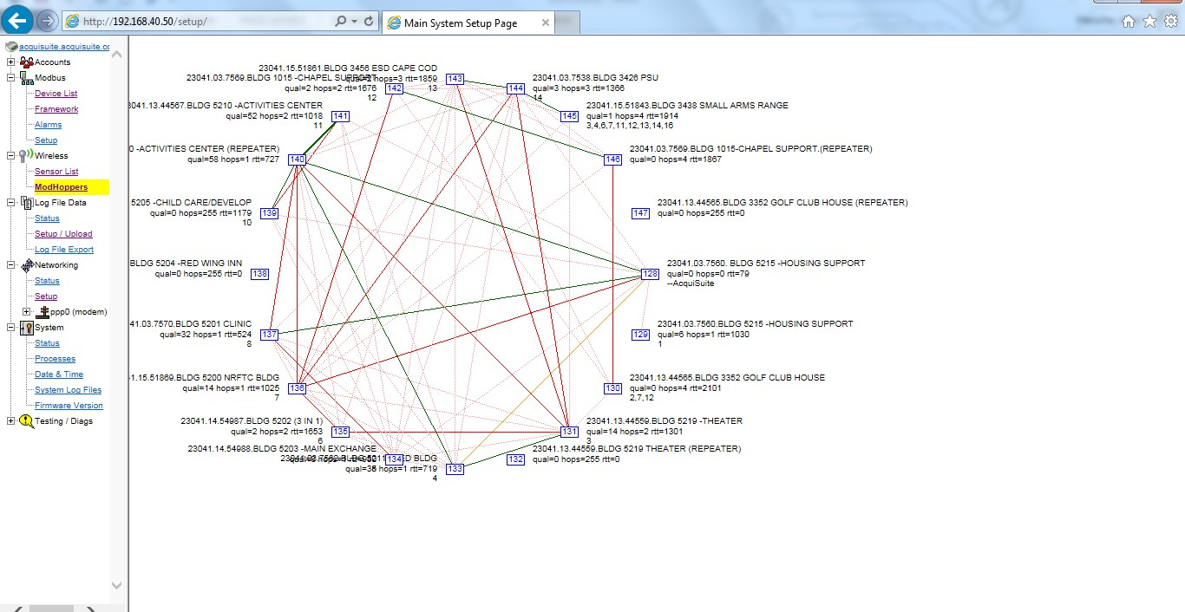
Figure 2 – Transceiver ModMesh

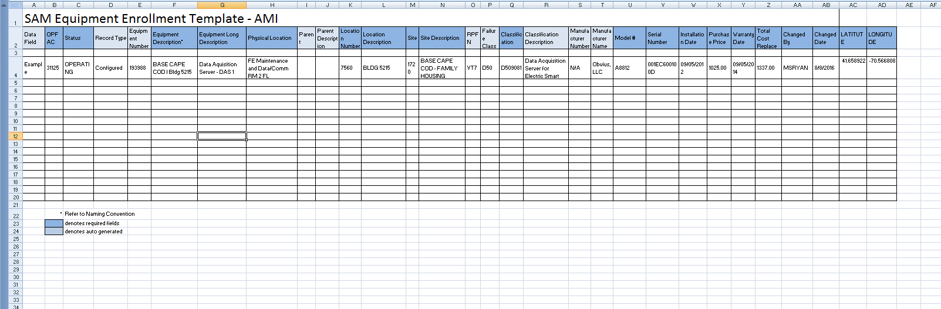
Figure 3 – Equipment Enrollment Template

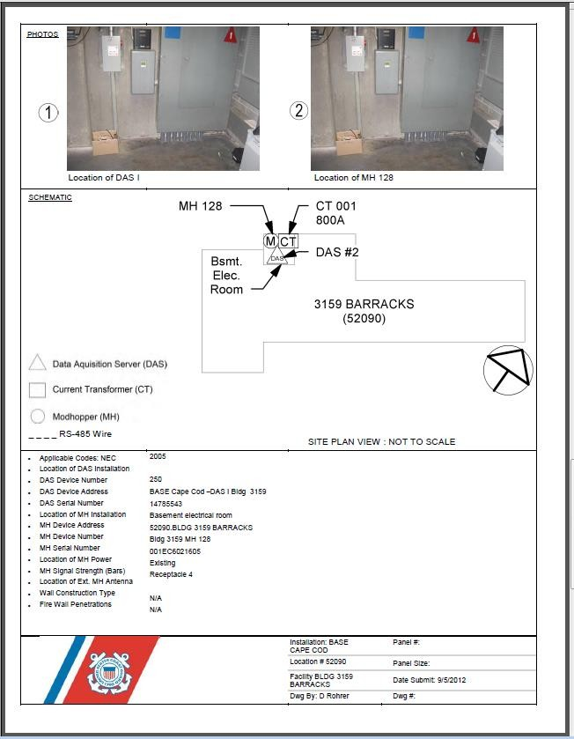

Figure 4 – Sample As-Built

Appendix F – Advanced Metering Equipment Naming Convention

The Coast Guard has established naming convention for advanced metering equipment is as follows:

- Data Acquisition Server (DAS)

Unit Name - DAS #(Roman Numeral) –Bldg#(or Name if no #) where located:
    - If the DAS serves Housing- add Housing after Bldg #.
    - DAS # begins with I (roman numeral).

Example: BASE KODIAK I - Bldg 26 or BASE KETCHIKAN II – FRC – Housing.
    - MODBUS Device # for DAS is always 250 (different than DAS #).
- Transceiver – Modhopper (XCRV)

Bldg# and Name (if available) where located - Transceiver Device#:
    - Example: Bldg 1234- UPH- XCVR128 or Bldg 42-MWR-XCVR132.
    - MODBUS Device # is same as Transceiver (XCRV) # which begins with 128 at the DAS.
- I/O Flex Modules or HD Pulse Modules (IOM)

Bldg# and Name (if available) where located, I/O Flex#:
    - Example: Bldg 1234-UPH-IOM201.
    - MODBUS Device # is same as I/O Flex# begins with 200.
- Meters (EAM,GAM,WAM)
  - Facilities/Equipment/Shore Ties – Small Boats

RPUID#*-Bldg # **and Bldg Name (if Available)or Equipment Name-Meter Type***
      - Example: 66031-Bldg17-Multi-Purpose-NGAM001****
      - MODBUS Device # for Meter begins with 1.
  - Shore Ties – Cutters (65’ and above)

Boat Length-Boat Type -Meter Type.
      - Example: 65’-WYTL-Electric.
*RPUID for Equipment – use RPUID of Building where equipment is housed. RPUID for Shore tie Small Boats– use RPUID of the Pier/Wharf where located.
**For multi-family buildings – include A/B/C/D with Bldg# Ex.- 12345 Bldg 23A Housing Water.
*** For Pulse Meters use PEAM, PWAM, PGAM.
**** For [type] Gas use N for Natural, LP for Liquid Propane.

#

